The Reading Mountain

Task #7. Book Character Interview.

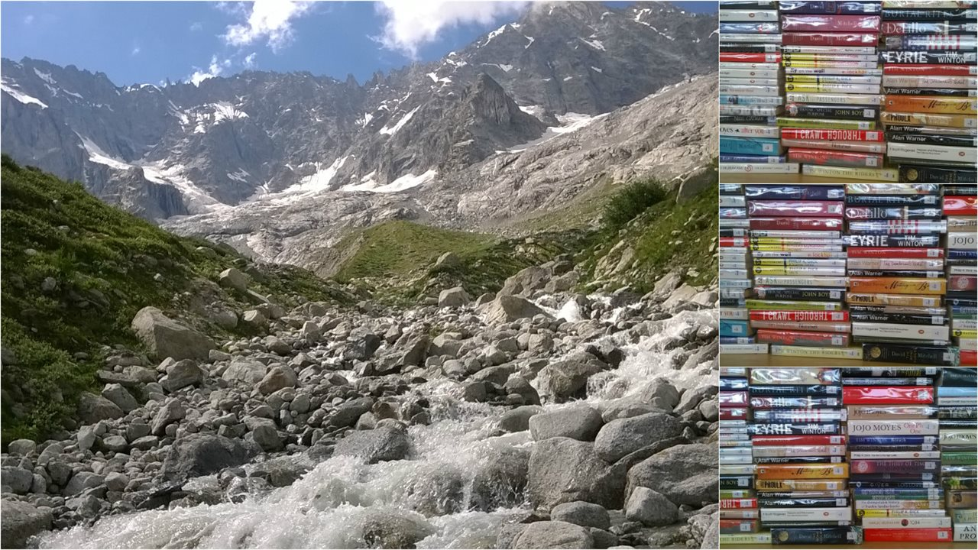
Book Read |  | Reading Trail (please tick √)
Title |  | Grand-Signal
Author |  | Cry D’Er
Date Finished |  | Les Violettes
 |  | Aminona (own choice)

Well done for finishing one of the excellent books from our Reading Mountain Reading Trails.

What you have to do:
- Pretend you are a famous Journalist and you have arranged to interview one of the characters from the book you have just finished reading.
Do:
- Mention the author, title and the year it was published.
- Describe the setting, (place, time, Real World or Fantasy)
- Ask the character how they feel about their part in the story.
- Write the interview conversation as a series of questions by you and answers by the character.

Don’t:
- Just re-tell the story.
- Worry if your questions are not realistic.

To request this task to be assigned to you. Click Here
Complete the submission form and a teacher will approve and assign the task to you on Firefly. Mark as completed when you are done, upload to the Library Catalogue and receive a 2nd House Point!

